**Lab#10(a) Setup a Laravel project for Book Inventory.**

|  |  |  |
| --- | --- | --- |
| **COMMAND USED** | **ATTRIBUTES USED** | **DESCRIPTION** |
| Composer | -- | In Laravel, Composer is a powerful dependency management tool for PHP that is widely used to manage the libraries, packages, and dependencies your Laravel application relies on. |

**Final Outcome:**

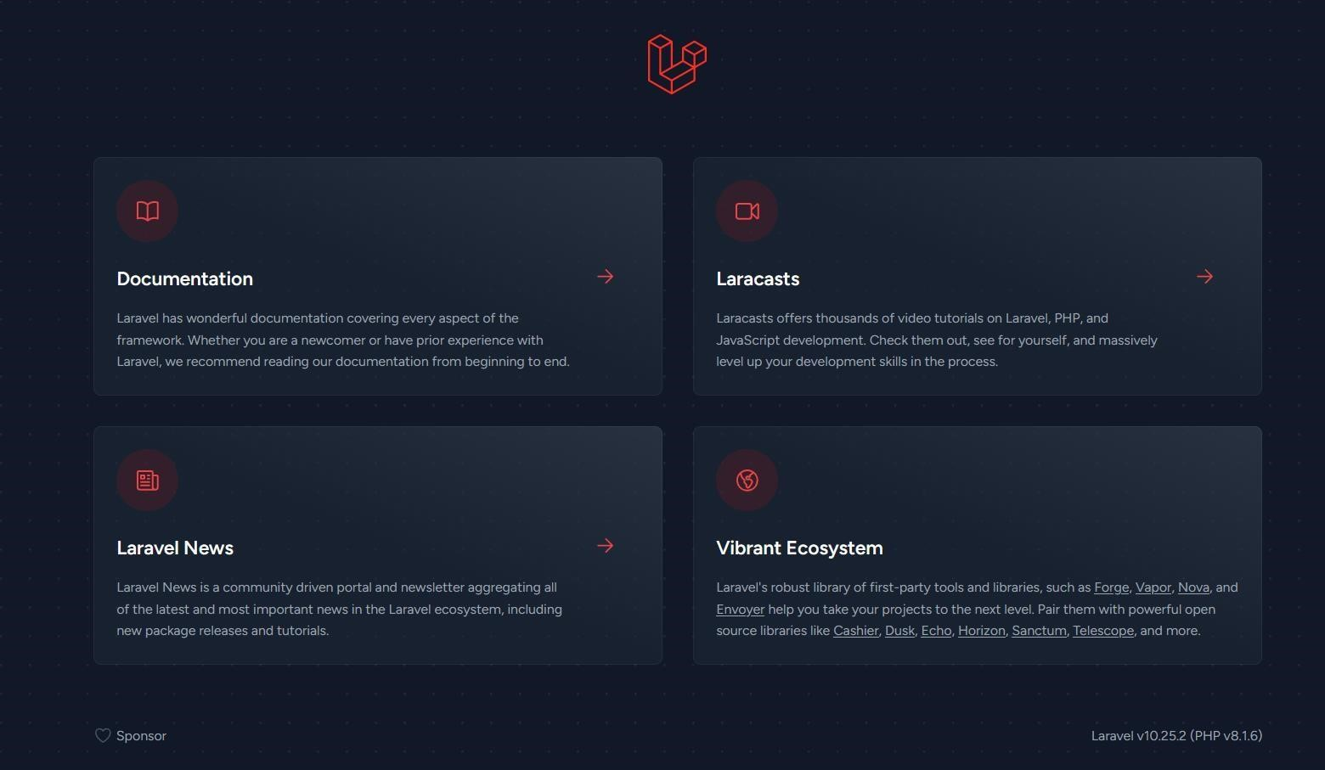

**Code Snippet:**

Open your terminal or command prompt and navigate to the directory where you want to create your Laravel project.

Run the following command to create a new Laravel project named "BookInventory":

Bash:

*composer create-project --prefer-dist laravel/laravel BookInventory*

Change into the project directory:

Bash: *cd BookInventory*